**Name: John Patrick E. Perilla**

6. Find employees with firstname containing **'an'**.

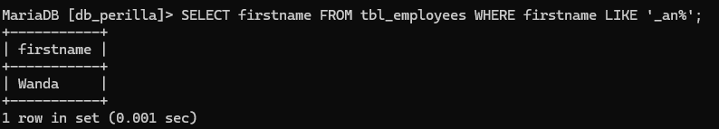

1. Find employees whose firstname second letter is **'e'**.

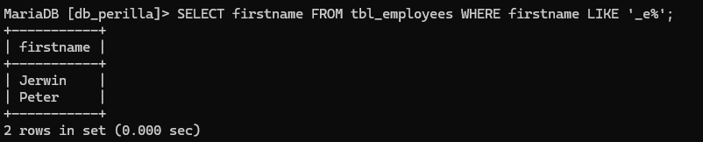

1. Find employees whose lastname starts with **'R'**

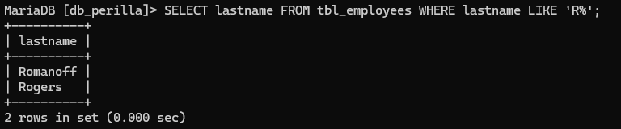

1. Show distinct position_id values.

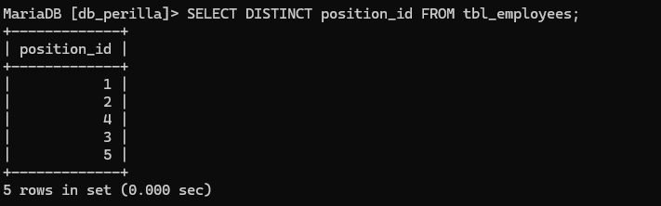

1. Show distinct gender values from the table.

